ENLISTMENT OF SECTORAL EXPERTS/TRAINERS
FOR CONDUCT OF TRAINING ON ENERGY AUDITING/MANAGEMENT

The Energy Conservation Fund working under National Energy Efficiency and Conservation Authority intends to engage the services of trainers/professionals/engineers/sectoral experts to conduct the training of trainer program on energy auditing and management.
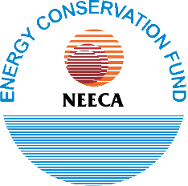
The interested applicants having a minimum of 16 years of education with 10-15 years of professional experience in energy, power, building, industry, transport, or agriculture sector may apply online on NEECA webpage (www.neeca.gov.pk) within 15 days from the date of publication of this advertisement. The shortlisted applicants will be called for interview and successful candidates will be enlisted and engaged by Energy Conservation Fund-NEECA on as and when required basis.

Manager Technical-ECF
NEECA Building, Sector G-5/2, Islamabad.
Phone: 051-2272649

